CREATE VIEW age_count AS SELECT M.year_of_release - CAST(A.birth_date AS INTEGER) AS age, COUNT(A.actor_id) AS actresses_played_movies FROM final.actors A INNER JOIN final.movie_actors MA ON A.actor_id=MA.actor_id INNER JOIN final.movie M ON MA.movie_id=M.movie_id WHERE M.year_of_release IS NOT NULL AND A.birth_date IS NOT NULL AND A.gender = 'f' AND M.year_of_release - CAST(A.birth_date AS INTEGER) BETWEEN 0 AND 100 GROUP BY M.year_of_release - CAST(A.birth_date AS INTEGER) ORDER BY age;

> ageCount <- dbReadTable(con, c("final","age_count"))

> model=lm(actresses_played_movies~., data=ageCount)

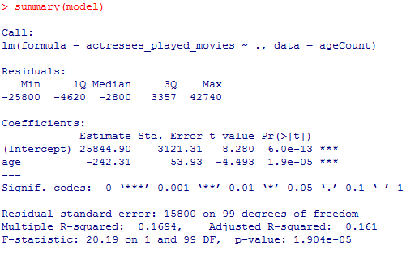

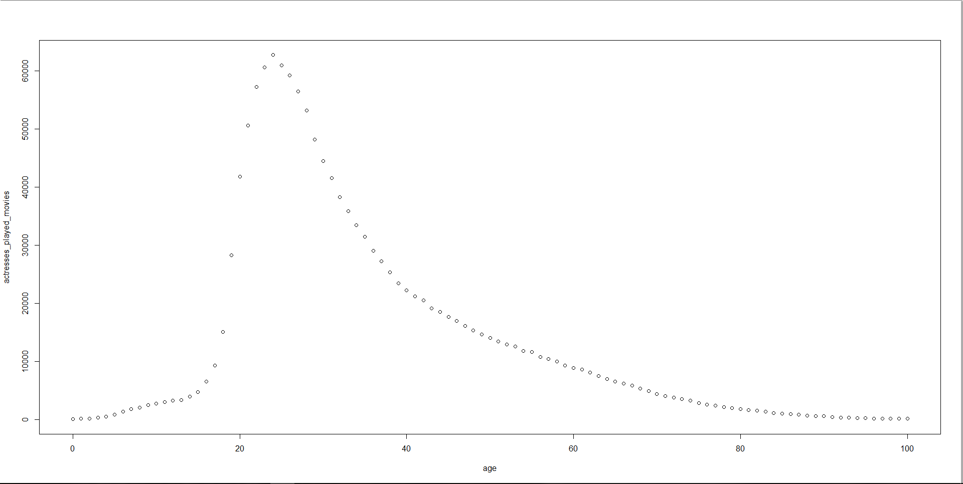> plot(ageCount)